CORRUPTION IN CHICAGO AND ILLINOIS

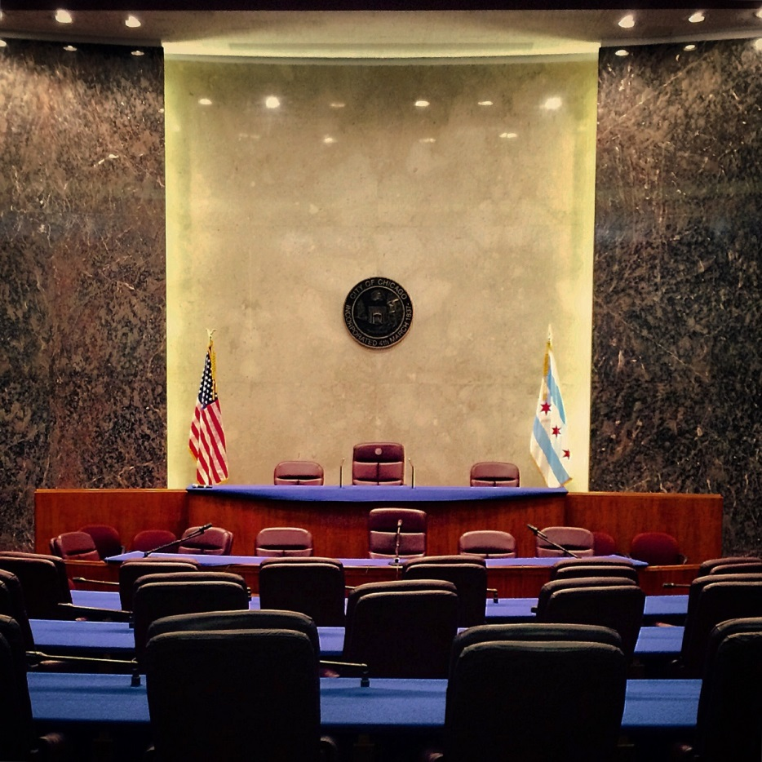

Anti-Corruption Report #11
February 11, 2019

Authored by
Dick Simpson
Thomas J. Gradel
Marco Rosaire Rossi

University of Illinois at Chicago
Department of Political Science
The number of federal convictions for public corruption in the "stinky onion" metropolis has declined recently but over the long haul Chicago continues to be the most corrupt big cities in the nation. Additionally, Illinois remains the third most corrupt state when compared on a per capita basis to other large states and the District of Columbia.
During 2017, the latest years for which figures from the U.S. Department of Justice (DOJ) are available, there were 25 public corruption convictions in the Northern District of Illinois, which includes all of Chicago and the northern third of Illinois. This is down from 30 in 2016 and down from an average of 33.6 per year over the last 10 years. There were a total of 34 cases of public corruption convictions in all of Illinois, proving that public corruption is not just a big city problem.
Statistics compiled by the DOJ's Public Integrity Section show that from 1976 through 2017, a total of 1,731 individuals were convicted of public corruption in the Northern District of Illinois (Chicago). In the same time period, the Central District of California (Los Angeles) convicted 1,534; the Southern District of New York (Manhattan), 1,327; Florida Southern (Miami) 1,165; and the District of Columbia (Washington), 1,159. These five districts, Chicago, Los Angeles, Manhattan, Miami and Washington D.C. led all of the 93 federal judicial districts for the 47-year period since 1976.
Since the DOJ provides public corruption statistics by state and because state population figures are available, we are able to make state-to-state per-capita comparisons.
On a per capita basis, Illinois is the third most corrupt state. While California, Texas, Florida, and New York each have more public corruption convictions than Illinois, their populations are larger than Illinois,' and therefore, they rank lower on a per capita basis. Pennsylvania's rank is lower both because its total number of convictions is lower and its total population is larger.
Below are several public corruption stories highlighted in the news media in 2017.
On April 28, 2017, Barbara Byrd Bennett, Chief Executive of Chicago Public Schools, was sentenced to 4.5 years in federal prison after pleading guilty to wire fraud as part of a scheme to grant a lucrative no-bid contracts in exchange for bribes that totaled more than $23 million. The bribes were offered by Supes Academy and Synesi Associations. In 2016, Gary Solomon and Thomas Vranas, owners of the two companies, pled guilty to wire fraud and bribery for their involvement in the scheme. Solomon was sentenced to 7 years in prison; Vranas was sentenced to 18 months.
November 13, 2017, indicted Chicago Alderman Willie Cochran (20th Ward), collapsed during a council meeting at City Hall. He had been indicted in 2016 on 15 counts of wire fraud, bribery, and extortion. Federal prosecutors had filed the charges after The Chicago Sun Times reported that Cochran—over a three-year period—illegally paid himself more than $115,000 from his campaign funds. The allegations triggered a federal investigation which turned up evidence that Cochran may have solicited a bribe of $1,500 from an Illinois attorney who represented developers in Cochran’s ward.
Later Cochran's lawyers filed a motion to suppress the evidence collected against him by federal agents. The motion failed.
After he had collapsed in 2017, he was revived through the use of CPR, and he later returned to serve in City Council. Although he first decided to plead guilty, he then changed his mind. As this report was being prepared, Cochran was still a member of City Council. His trial is scheduled for June, 2019.
Also in 2017, former U.S. Rep. Aaron Schock who had been charged with a 24-count indictment for misusing campaign and office funds, managed to get his trial delayed and had some charges dropped from the indictment. Schock came to the attention of US Attorney’s Office after news stories were published on his lavish spending for travel, entertainment, and office remodeling. . Shock's trial was originally scheduled for July 11, 2017, but delayed until January of 2018, and then delayed again because the judge overseeing Schock’s trial was removed and the Justice Department has decided to switch prosecutors.
In February of 2017, the Cook County State Attorney Kim Foxx agreed to look into hundreds of convictions involving former Police Officer Ronald Watts. State Attorney Kim Foxx won an election in 2016 on a reform agenda that promised to deal with abuses in Cook County’s criminal justice system. Three years earlier, Watts was sentenced to 22 months in a federal prison for stealing thousands of dollars from a drug courier who was secretly an FBI informant. In November of 2017, at the behest of State Attorney Kim Foxx, Judge LeRoy K. Martin approved a motion to vacate the convictions of 15 men who were framed by Watts. It was a historical exoneration that has led to a review of other possible wrongful conviction in Cook County.
Altogether there were 25 Chicago corruption convictions in 2017 and 34 for the State of Illinois. But this was only a prelude to 2018 and 2019 when Chicago made national headlines as still the corruption capital of the nation.
In a February 5th, 2018, an article in the New York Times, the newspaper included Chicago among “Four of America's largest cities (that) are under the dark clouds of major federal corruption investigations. Residents, politicians, and power brokers in all of them are holding their breath, waiting for signs of how deeply their civic cultures will be shaken." The Times article, written by Richard Fausset, Monica Davey and Tim Arango, states that the investigations in Atlanta, Los Angeles, Chicago, and Philadelphia raise questions about "whether there can be any lasting cure for the chronic corruption problems that seem to dog big cities, so often dominated by a single party or political machine."
Reforms in Cook County’s criminal justice system and the overall decade-long decline in Chicago's total public corruption convictions per year may be encouraging. Nevertheless, the electorate was jolted back to reality of Chicago’s “chronic corruption problems” when the U.S. Attorney charged Edward Burke, Chicago's most powerful Alderman and Chairman of the City Council's Finance Committee, with attempting to extort a restaurant owner. The charges against Ald. Burke (Ward 14); the revelation that the FBI taped his phone for more than a year; and news that Alderman Daniel Solis (Ward 25) is under investigation and cooperating with federal prosecutors became known just four weeks before Municipal elections on February 26th.
In response to the high level of corruption and the new Burke/Solis scandals, the fourteen candidates for Mayor of Chicago rolled out various proposals for reform. While different candidates offered different anti-corruption plans, most of the candidates agreed with banning or limiting outside income for aldermen, eliminating the practice of aldermanic privilege, term limits for the mayor and alderman, and expanding the powers of the city's inspector general. Several candidates called for a ban on the city hiring or doing business with family members of aldermen, and some recommended public financing of campaigns. Various aldermanic candidates have joined in supporting these reforms.

Table 1:
Federal Public Corruption Convictions by Judicial District 1976-2016
Rank for Conviction | District  (Major City) | 2010-17 | 2000-09 | 1990-99 | 1976-89 | 1976-2017
1 | Illinois-Northern  (Chicago) | 246 | 367 | 610 | 508 | 1,731
2 | California-Central  (Los Angeles) | 288 | 383 | 595 | 268 | 1,534
3 | New York-Southern  (Manhattan) | 137 | 242 | 398 | 550 | 1,327
4 | Florida-Southern  (Miami) | 216 | 404 | 437 | 108 | 1,165
5 | District of Columbia | 185 | 342 | 393 | 239 | 1,159
6 | New Jersey  (Newark) | 237 | 410 | 264 | 202 | 1,113
7 | Pennsylvania-Eastern  (Philadelphia) | 220 | 252 | 246 | 291 | 1,009
8 | Virginia-Eastern  (Richmond) | 296 | 303 | 213 | 189 | 1,001
9 | Ohio-Northern  (Cleveland) | 171 | 333 | 314 | 173 | 991
10 | New York-Eastern  (Brooklyn) | 97 | 204 | 237 | 308 | 846
11 | Texas-Southern  (Houston) | 224 | 267 | 205 | 116 | 812
12 | Florida-Middle  (Orlando) | 171 | 230 | 179 | 159 | 739
13 | Massachusetts  (Boston) | 141 | 187 | 159 | 193 | 690
14 | Louisiana-Eastern  (New Orleans) | 156 | 230 | 173 | 117 | 676
15 | California-Eastern  (Sacramento, Fresno) | 90 | 200 | 203 | 156 | 649

Table 2:
Federal Public Corruption Convictions Per Capita
Top Thirteen States with Most Convictions 1976-2016
Rank for Convictions Per Capita | State |  | Convictions  1976-2017 | Population  2015 | Conviction  Per 10,000 Population | Increase/  Decrease Conviction Per Capita from 2016
1 | District of Columbia |  | 1,159 | 672,228 | 17.24
2 | Louisiana |  | 1,202 | 4,670,724 | 2.57
3 | Illinois |  | 2,102 | 12,859,995 | 1.63
4 | Tennessee |  | 1,015 | 6,600,299 | 1.54
5 | New York |  | 2,860 | 19,795,791 | 1.44
6 | Pennsylvania |  | 1,808 | 12,802,503 | 1.41
7 | Virginia |  | 1,158 | 8,382,993 | 1.38
8 | Ohio |  | 1,549 | 11,613,423 | 1.33
9 | New Jersey |  | 1,113 | 8,958,013 | 1.24
10 | Georgia |  | 1,115 | 10,214,860 | 1.09
11 | Florida |  | 2,166 | 20,227,272 | 1.07
12 | Texas |  | 2,249 | 27,469,114 | .82
13 | California |  | 2,864 | 39,144,818 | .73

